Title of the manuscript (Style: Heading 1)

Authors of the manuscript (style: Author) first name, surname. Presenter underlined

Affiliation (Style: Affiliation) Business affiliations and addresses of the authors, using superscript numbers to refer to each author
Corresponding author (Style: email): First name, surname: <email:address>

Abstract (style: Heading 2)
Text (Style: Body)

Introduction (style: Heading 2)
Text (Style: Body)

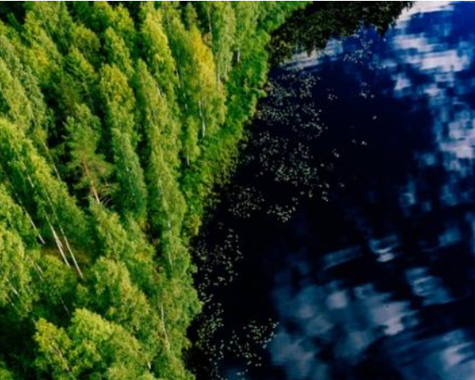
Figure 1. Title (Style: Picture)
Number all figures and illustrations as Figure 1, Figure 2 and refer to them in your text accordingly. Captions should be below Figure. All figures and illustrations should be included in the text.

Experimental (style: Heading 2)
Text (Style: Body)

Table 1. Title (Style: Table)
Table Design style: NWBC, Table text style: Content
Column 1 | Column 2
Row 1 | Row 1
Row 2 | Row 2

Number all tables as Table 1, Table 2 and refer to them in your text accordingly. Captions should be above Table. All tables should be included in the text.

Results and discussion (style: Heading 2)
Text (Style: Body)

Conclusions (style: Heading 2)
Text (Style: Body)

Acknowledgements (style: Heading 2)
Text (Style: Body)

References (style: Heading 2) Reference style APA
Use the following styles (APA) when listing the refences. The references need to be listed in text e.g. (Virtanen. 2022), (Virtanen & Torvinen, 2020) or (Virtanen et al. 2021).
Journal:
Torvinen, K., Lehtimäki, S., Keränen, J. T., Sievänen, J., Vartiainen, J., Hellén, E., ... & Tuukkanen, S. (2015). Pigment-cellulose nanofibril composite and its application as a separator-substrate in printed supercapacitors. Electronic Materials Letters, 11(6), 1040-1047. https://doi.org/10.1007/s13391-015-5195-6

Book Chapters:
Surname, L., & Surname, E. P. (Year). Chapter title. In Book name (pp. 83-117). Publisher, Town, Country.
Conference:
Torvinen, K., Mäkelä, T., Khakalo, A., & Tammelin, T. (2019, June). Substrates based on cellulose nanofibrils for printed electronics and optics. In International Conference on Nanotechnology for Renewable Materials 2019 (pp. 279-289). TAPPI Press.

